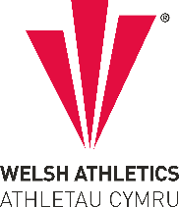
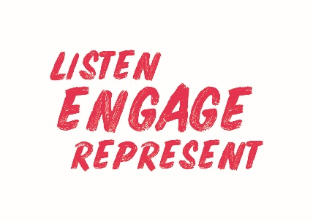
Welsh Athletics Endurance Officials Meeting Minutes
Held on the Monday 5 February 2024
Meeting held remotely via video link

Present: Nigel Jones (Chair) Christine Vorres, Jacqueline Brace, Zoe Holloway. Paul Brooks,
- Apologies: Alex Donald

Actions from this meeting:
Item Number | ACTIONS | Person responsible
3a | Write to James Williams re decision on Official’s expenses | NJ
3a | Set up Risk Awareness courses | ZH
3a | Send out details of Meeting Manager role to Martyn Jenkins and ask if mentoring/shadowing welcomed? | CV/ ZH

2. Declaration of Interest – None declared
3. Decisions:
a) Matters arising from previous meeting:-
- Communication with James Williams regarding Official’s expenses still ongoing –
- Organisation of Risk Awareness courses still be explored – may piggy-back England Courses.

- Discussion
4a – Zoe – an email was sent to the Officials for the School’s XC event. At the moment the cross-country events are in a good position in respect of Officials and marshalls. One Official (Martyn Jenkins) has questioned his allocated role – the members agreed that if he is willing, it will be good development for him. It was agreed to send him a breakdown of the role allocated and to offer ‘mentoring’
4b – 2024 Virtual Endurance Officials Conference
Arwell Lewis will run a session on Mountain/Trail Running Officiating.
Alex Donald will not be available for the Conference.
Track and Field Conference running a session to recap on Rules – maybe do something similar for Endurance Officials. Needs to be explored to find out what new rule are applicable.
The members discussed when details of the Conference will be sent out and possible scenarios to include for workshops.
4c – Feedback from General Council Meeting:
CV – there was very little to report that was relevant to Endurance Officials. The race selection committees had yet to meet to advise endurance Championship races
4d – New Welsh Athletics Event Licensing Platform
CV has been testing the new system and there are still areas that need to be developed. JB agreed that it is still a little way off being completed but big steps have been made. 40 licenses have already been approved on the Run Britain website. There was a discussion on Medical Cover and the need to tighten up on what is offered at events and what is actually required.
- Update on Official’s Development Pathway
ZH presented a proposed new development pathway for Endurance Officials and explained the changes from current pathway to new proposals. If signed off the strategy will be adopted from 1st April.

- Correspondence
None received

- AOB:
96% of Officials have now accepted the new terms and conditions – any that have not will be shortly made ‘inactive’ Zoe will compile a list of those who need to comply.
The members discussed proposed events for the Inter-regional and national championships.

The meeting ended at 7.30pm .
Future meetings:
April 8th 2024
June 3rd 2024
August 5th 2024
October 7th 2024
December 2nd 2024
Minutes written by Chris Vorrés. 6 February 2024

